**Source Code:**

#include <iostream>

#include <string>

**using** **namespace** std;

**struct** dataBuku

{

string idBuku;

string namaBuku;

string hargaBuku;

};

**int** main()

{

**int** arraySize = 10;

dataBuku arrayBuku[arraySize];

arrayBuku[0] = {"101", "C++", "5000"};

arrayBuku[1] = {"102", "Java", "10000"};

arrayBuku[2] = {"103", "PHP", "6000"};

**char** tab = '\t';

**int** choice;

cout << "|====================|" << endl;

cout << "| MENU |" << endl;

cout << "|====================|" << endl

<< endl;

cout << "1. Tambah data buku" << endl;

cout << "2. Cetak data buku" << endl;

cout << "3. Ubah harga buku" << endl;

cout << "4. Keluar" << endl

<< endl;

cout << "Pilih menu : ";

cin >> choice;

cout << endl;

**if** (choice == 1)

{

string tempID, tempHarga;

string tempNama;

cout << "ID Buku : ";

cin >> tempID;

cout << "Nama Buku : ";

cin >> tempNama;

cout << "Harga Buku : ";

cin >> tempHarga;

arrayBuku[3].idBuku = tempID;

arrayBuku[3].namaBuku = tempNama;

arrayBuku[3].hargaBuku = tempHarga;

cout << "\nData berhasil ditambah!" << endl;

cout << "\nNo.\tID Buku\t\tNama Buku\tHarga Buku" << endl;

**for** (**int** j = 0; j < 4; j++)

{

cout << j + 1 << tab << arrayBuku[j].idBuku << tab << tab << arrayBuku[j].namaBuku << tab << tab << "Rp." << arrayBuku[j].hargaBuku << endl;

}

}

**else** **if** (choice == 2)

{

cout << "No.\tID Buku\t\tNama Buku\tHarga Buku" << endl;

**for** (**int** j = 0; j < 3; j++)

{

cout << j + 1 << tab << arrayBuku[j].idBuku << tab << tab << arrayBuku[j].namaBuku << tab << tab << "Rp." << arrayBuku[j].hargaBuku << endl;

}

}

**else** **if** (choice == 3)

{

string idChange, hargaSblm, hargaStlh;

cout << "Masukkan ID Buku : ";

cin >> idChange;

cout << "Masukkan harga baru :";

cin >> hargaStlh;

**for** (**int** j = 0; j < 3; j++)

{

**if** (arrayBuku[j].idBuku == idChange)

{

hargaSblm = arrayBuku[j].hargaBuku;

arrayBuku[j].hargaBuku = hargaStlh;

cout << "\nID buku : " << arrayBuku[j].idBuku << endl;

cout << "Nama buku : " << arrayBuku[j].namaBuku << endl;

cout << "Harga sebelum diubah : Rp " << hargaSblm << endl;

cout << "Harga setelah diubah : Rp " << hargaStlh << endl;

}

}

}

**else**

{

**return** 0;

}

}

**Result:**

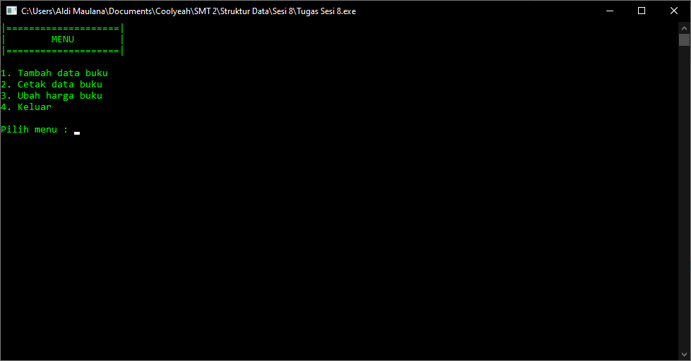

[*https://drive.google.com/file/d/1wtVxmZ9rOlGhGmk-14mr_B9KGVS6cHkK/view?usp=sharing*](https://drive.google.com/file/d/1wtVxmZ9rOlGhGmk-14mr_B9KGVS6cHkK/view?usp=sharing) *– Untuk Test*